Pyrolysis- isothermal and temperature linear with time.

The kinetic model referred to is from :

Pyrolysis of Thick Biomass Particles: Experimental and Kinetic Modeling **, Ranzi** et al. (**2013**)

Isothermal yields:

|  |  |  |  |  |  |  |  |  |
| --- | --- | --- | --- | --- | --- | --- | --- | --- |
| Cellulose | HemiC | Lignin | H2O | CO2 | CO | CH4 | Char | H2 |
| 0.25 | 0.2 | 0.55 | 2.3681 | 0.4780 | 4.6190 | 1.3325 | 12.672 | 1.643 |
| 0.3 | 0.2 | 0.5 | 2.1746 | 0.4865 | 4.1423 | 1.210 | 11.396 | 1.506 |
| 0.35 | 0.2 | 0.45 | 1.9812 | 0.4450 | 3.6654 | 1.0876 | 10.119 | 1.329 |
| 0.4 | 0.2 | 0.4 | 1.7877 | 0.4535 | 3.1855 | 0.9651 | 8.8427 | 1.232 |
| 0.35 | 0.25 | 0.4 | 1.7527 | 0.4932 | 3.2385 | 0.9891 | 8.8598 | 1.292 |
| 0.3 | 0.3 | 0.4 | 1.7177 | 0.5330 | 3.2885 | 1.0131 | 8.8767 | 1.352 |
| 0.35 | 0.3 | 0.35 | 1.6742 | 0.5440 | 3.1405 | 0.9608 | 8.2830 | 1.252 |
| 0.4 | 0.3 | 0.3 | 1.4808 | 0.5025 | 2.6636 | 0.8384 | 7.0064 | 1.116 |
| 0.45 | 0.3 | 0.25 | 1.3473 | 0.5020 | 2.3183 | 0.7440 | 6.0028 | 0.993 |

All quantities in the above table are in gram-moles.

For lignin, Lig-O,Lig-C and Lig-H were assumed to be roughly equal in quantity.

Key Observations

* Char content goes down steeply decrease in Lignin content mainly because there is more carbon in lignin (per mole).
* Methane, water vapour and hydrogen also decreases with decrease in Lignin.
* Carbon Dioxide increase with increase in Hemi-Cellulose.

**Temperature linearly increasing with time.**

The given kinetic model is probably accurate only for temperatures above 300oC . Firstly, since in the publication by Ranzi et al. It was used only for temperatures above 300oC. Secondly, the rate constants predict that the reaction would happen even at room temperatures when is definitely wrong, so it’s probably not useful at those temperatures.

Therefore, we start the process at 350oC .

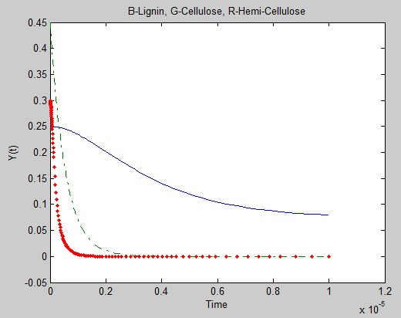

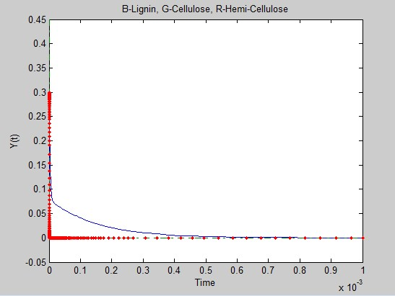

Lignin takes a much longer time to react compared to Cellulose and Hemi-Cellulose. (Especially Lignin- CC )

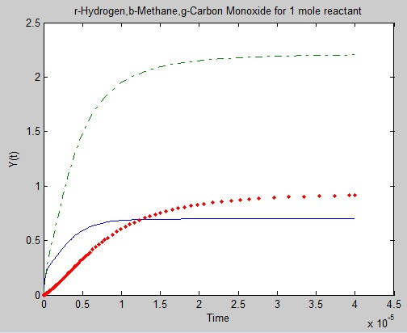

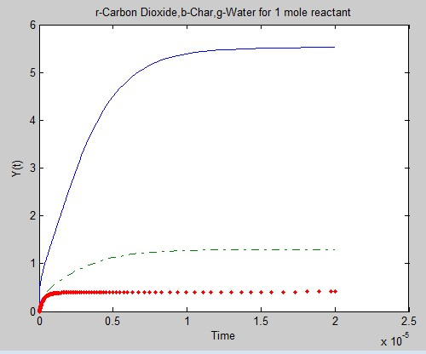

The heat rate was 500 K s-1  (extremely high), yet the reaction is completed within 10-3 seconds (The temperature at which is 350.5oC ). Therefore, by this kinetic model the reaction should complete very quickly even at lower temperatures of 350oC .